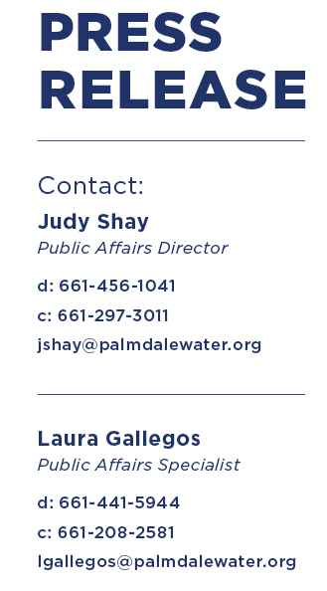October 14, 2021

**FOR IMMEDIATE RELEASE**

**AV & SCV SPECIAL DISTRICTS FORM FIRST CSDA LOCAL CHAPTER IN L.A. COUNTY**

*Palmdale*, CA– Special districts in the Antelope Valley and Santa Clarita Valley have formed Los Angeles County’s first local chapter of the California Special Districts Association (CSDA).

The local chapter, named the Special Districts Association of North Los Angeles County, will give Antelope Valley and Santa Clarita Valley special districts a stronger voice on the state level of the CSDA, which is a not-for-profit association formed in 1969 to promote good governance and improve core local services.

“CSDA chapters enhance collaboration and promote information and resource sharing in regions,” CSDA Senior Public Affairs Field Coordinator Chris Palmer said. “They allow special districts to expand their knowledge base and operate with increased efficiency by tapping into CSDA legislative activity and learning opportunities on a broad scale.”

(more)

CSDA…Page 2

The new chapter’s Board officers are represented by board directors and staff from Palmdale Water District (PWD), Santa Clarita Valley Water Agency (SCVWA) and Quartz Hill Water District (QHWD). The officers are President Vincent Dino, PWD Director; Vice President Kathye Armitage, SCVWA Director; Secretary Gloria Dizmang, PWD Director; Treasurer Kathie Martin, SCVWA Communications Manager; and Director-at-Large Drew Mercy, QHWD Director.

Last month, PWD and CSDA hosted the initial meeting to form the chapter and featured Los Angeles County Supervisor Kathryn Barger as the keynote speaker. She voiced her support for the local chapter and applauded the collaboration between the Antelope Valley and Santa Clarita Valley.

“I am the loudest advocate for local control,” Supervisor Barger said. “Too often, local jurisdictions, governments and special districts cede their voices to bigger organizations with bigger voices. Advocacy starts at the local level and is amplified when the community unites to speak with one voice. Although your needs, challenges and strengths vary from organization to organization, you all represent constituents who rely on your services in northern Los Angeles County.”

The agencies involved in the formation are the A.V. Air Quality Management District, A.V. Mosquito and Vector Control, A.V. Resource Conservation District, Littlerock Creek Irrigation District, PWD, QHWD, and SCVWA.

The local chapter will build a base in Los Angeles County and expand with interest from

(more)

CSDA…Page 3

other districts within the county. CSDA will support the local chapter by providing speaker suggestions, legislative updates, communication tools, and other local resources.

Since 1918, the Palmdale Water District has provided high-quality water at a reasonable cost. We pride ourselves on providing great customer care; advocating for local water issues that help our residents; educating the community on water-use efficiency; and leading our region in

researching and implementing emerging technologies that increase operational efficiency. For more information about PWD, visit [www.palmdalewater.org](http://www.palmdalewater.org).

###